Frequently Asked Questions for Announcement Forms - Interest Payment (for CCASS Eligible Debt Securities Issuers)
(Last updated on 10 Dec 2022)

Contents
Frequently Asked Questions for Announcement Forms - Interest Payment (for CCASS Eligible Debt Securities Issuers) 1
1. General 4
1.1 What are the types of Announcement Form? 4
1.2 Why do we introduce this e-Form? 4
1.3 When is the implementation date of the Announcement Form? 4
1.4 Will there be any transitional arrangement? 4
1.5 If debt securities issuers have any enquiries about the new e-Form, who should they contact? 5
1.6 In what circumstances should debt securities issuers publish Announcement Form? 5
1.7 If the information of a relevant corporate action (e.g. interest payment) has already been disclosed by a debt securities issuer in the results or other announcements, does it need to publish any Announcement Form? 5
2. ESS Submission flow and points to note 6
2.1 What type of user account that debt securities issuers should use to login into ESS for the publication of Announcement Form? 6
2.2 Which headlines should be selected for publication of Announcement Form? 6
2.3 Are debt securities issuers required to upload the English and Chinese versions of the Announcement Form separately? 7
2.4 Are debt securities issuers allowed to submit other format of document if they select the headlines for Announcement Form? 7
2.5 What should debt securities issuers do if there is an error message appears on ESS about the form version (e.g. “You are using an old Announcement Form version”) during submission? 7
2.6 What should debt securities issuers do if they wish to supplement any information on the Announcement Form? 8
2.7 How will the Announcement Form look like after they are published on the HKEXnews website? 8
2.8 Are debt securities issuers required to publish the Announcement Forms on their own website? 9
3. Sample scenario 9
3.1 What are the sample scenarios for different type of debt securities issuers to publish Announcement Form? 9
Scenario 1: Interest payment by a debt securities issuer 9
4. Exception scenario handling 9
4.1 What should a debt securities issuer do if it notes certain incorrect contents (e.g. wrong “status” or incorrect payment date) in a previously published Announcement Form? 9
4.2 What should a debt securities issuer do in the following circumstances? 10
4.3 What should a debt securities issuer do if it notes that there is an error red box in the e-Form even all the mandatory fields are filled in? 10

General

1.1 What are the types of Announcement Form?
The Exchange will introduce the following e-Form for debt securities issuers to make announcements through HKEXnews website:
- Announcement Form relating to interest payment:
- Interest Payment Announcement Form (EF006)

1.2 Why do we introduce this e-Form?
The Announcement Form is introduced with the following aims:
- to standardise the presentation of routine information and allow for easier comparison by investors between debt securities issuers;
- to reduce the risk of manual input error through the use of data validation in the e-Form; and
- to assist the Exchange in collecting and analysing data more efficiently.

1.3 When is the implementation date of the Announcement Form?
The Announcement Form will be available for download and submission at the e-Submission System (ESS) from 18:00 on 11 July 2021.

1.4 Will there be any transitional arrangement?
Announcement Forms
There is a transitional period for Announcement Form from 11 July 2021 to 5 September 2021. During the transitional period, debt securities issuers are encouraged to publish Announcement Form for any interest payment and any updates or cancellation of such interest payment. With effect from 6 September 2021, debt securities issuers should use Announcement Form to announce all interest payment.
Please also note that debt securities issuers should use Announcement Form to disclose any updates or cancellation of their interest payment initially announced using Announcement Form. Otherwise, debt securities issuers should use the existing announcement format to publish the update or amendment.

1.5 If debt securities issuers have any enquiries about the new e-Form, who should they contact?
Debt securities issuers may contact the Exchange’s officers through the following channels:
Enquiries relating to | Contact
- Matters relating to Announcement Form (e.g. how to fill in the Announcement Form, meaning of error message, etc.) | For Announcement Form  Post trade  at (+852) 2211 5780 or email at HKSCCN_CAMS@HKEX.COM.HK
- ESS user administration and general submission procedures | ESS Hotline  at (+852) 2840 3460 or email at ESSHotline@hkex.com.hk

1.6 In what circumstances should debt securities issuers publish Announcement Form?
Debt securities issuers should publish Announcement Form to announce all new interest payment.

Debt securities issuers should also publish Announcement Form for any subsequent update, amendment or cancellation of the interest payment initially announced using Announcement Form, for example:
- Update on the administrative arrangements (e.g. interest rate, payment date etc.)
- Cancellation or withdrawal of interest payment either by decision of the debt securities issuers’ management or if voted down by shareholders

1.7 If the information of a relevant corporate action (e.g. interest payment) has already been disclosed by a debt securities issuer in the results or other announcements, does it need to publish any Announcement Form?
Yes, the debt securities issuer is required to publish Announcement Form for any interest payment, irrelevant of whether the same information has already been covered in the results announcements or other announcements.

ESS Submission flow and points to note
3. Upload the e-Form, select its Form Type, Previous Related Submission and/or upload additional documents
1. Login into ESS as Publication Related Matters user
5. Document published on HKEXnews website
4. Approve the publication
2. Fill in submission details and select headline category

2.1 What type of user account that debt securities issuers should use to login into ESS for the publication of Announcement Form?
Similar to the existing publication procedure, debt securities issuers should login into ESS as a “Publication Related Matters” user in order to submit and publish Announcement Form.

1. Login into ESS as Publication Related Matters user
4. Approve the publication
2. Fill in submission details and select headline category
3. Upload the e-Form, select its Form Type, Previous Related Submission and/or upload additional documents
5. Document published on HKEXnews website

2.2 Which headlines should be selected for publication of Announcement Form?
Debt securities issuers can only submit Announcement Form with the selection of the below designated headlines (Note):
Announcement Form
Form Type | Tier 1 headline | Tier 2 headline
Interest Payment Announcement Form (EF006) | Debt and Structured Products | Interest Payment (Announcement Form) – Debt Securities

Note: Debt securities issuers are not allowed to select additional headlines or make subsequent change on the selected headline after publication of the Announcement Form.

1. Login into ESS as Publication Related Matters user
4. Approve the publication
2. Fill in submission details and select headline category
3. Upload the e-Form, select its Form Type, Previous Related Submission and/or upload additional documents
5. Document published on HKEXnews website

2.3 Are debt securities issuers required to upload the English and Chinese versions of the Announcement Form separately?
The Announcement Form contain both English and Chinese versions. Debt securities issuers are only required to upload one duly completed Announcement Form, and ESS will then separately publish the corresponding English and Chinese versions on the HKEXnews website. This is different from the existing publication procedure where debt securities issuers have to submit the English and Chinese version of documents separately.

2.4 Are debt securities issuers allowed to submit other format of document if they select the headlines for Announcement Form?
ESS will check the submitted document against the selected form type, and will only process the document with correct format. However, debt securities issuers could submit additional documents as supplemental disclosure (see Section 2.6 of this FAQ).

2.5 What should debt securities issuers do if there is an error message appears on ESS about the form version (e.g. “You are using an old Announcement Form version”) during submission?
ESS will only accept and publish Announcement Forms of the latest version. Debt securities issuers can check the version number on the bottom right corner of their forms and download the latest version of these forms in ESS or the HKEX website (https://www.hkex.com.hk/Listing/Rules-and-Guidance/eForm-Corner?sc_lang=en).

2.6 What should debt securities issuers do if they wish to supplement any information on the Announcement Form?
Debt securities issuers can upload additional documents together with the Announcement Form. When the additional documents are submitted with the Announcement Form, it will be displayed on the HKEXnews website as a multi-files document format:

Announcement Form
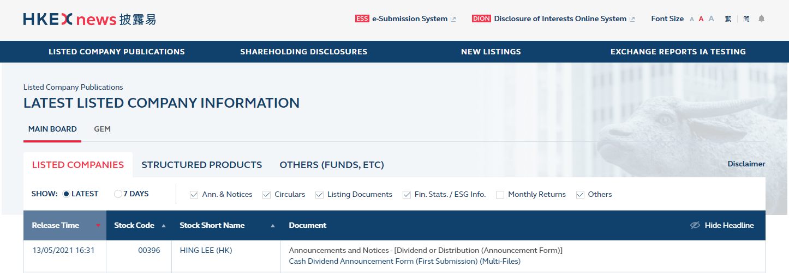

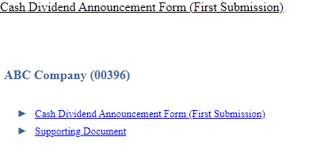
1. Login into ESS as Publication Related Matters user
4. Approve the publication
2. Fill in submission details and select headline category
3. Upload the e-Form, select its Form Type, Previous Related Submission and/or upload additional documents
5. Document published on HKEXnews website

2.7 How will the Announcement Form look like after they are published on the HKEXnews website?
The Announcement Form published on the HKEXnews website will be in a read-only PDF file format which is not editable. Please see below sample file:

2.8 Are debt securities issuers required to publish the Announcement Forms on their own website?
Yes, debt securities issuers can download the read-only files from the HKEXnews website for publication on their own websites.

Sample scenario

3.1 What are the sample scenarios for different type of debt securities issuers to publish Announcement Form?

Scenario 1: Interest payment by a debt securities issuer

Timetable | Description
Day 1 | The debt securities issuer publishes its interest rate which quarterly interest will be paid. Interest calculation and payment arrangement are also included.

Day 1
The debt securities issuer should submit one Announcement Form in HKEXnews simultaneously:
- For the interest payment: Interest Payment Announcement Form choosing “Interest Payment (Announcement Form) – Debt Securities” as its headline. Please refer to the below sample of Announcement Form published on this stage:
Note 1: The debt securities issuers should select “New announcement” as the status as it is a new interest payment.

Exception scenario handling

4.1 What should a debt securities issuer do if it notes certain incorrect contents (e.g. wrong “status” or incorrect payment date) in a previously published Announcement Form?

Note: Please note that debt securities issuer needs to cancel the Announcement Form with wrongly selected “status” field. Please refer to Section 4.2 of this FAQ for the cancellation procedures.

Announcement Form
- The debt securities issuer should publish a new Announcement Form with the revised content, choose “Update to previous announcement” in the “status” field and provide the reason for the update / withdraw.
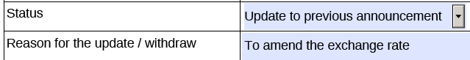
- When the debt securities issuer submits the new Announcement Form through ESS, it should select the previously published Announcement Form that it wishes to update or amend.
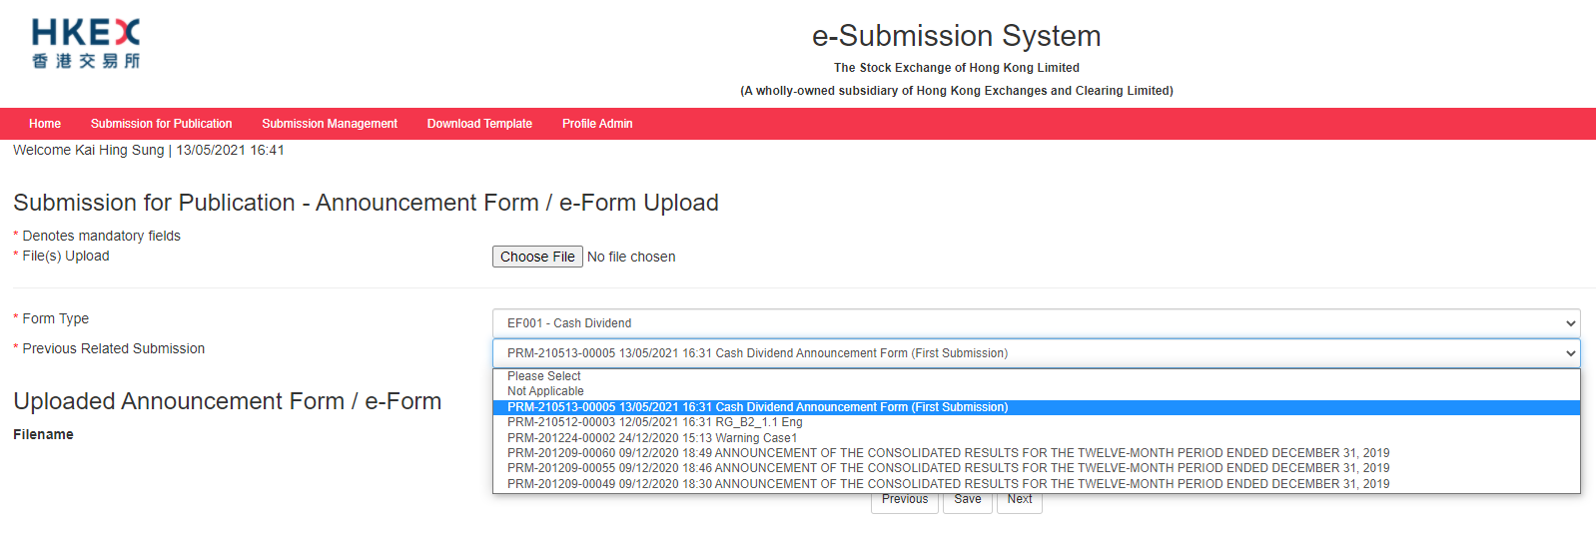

4.2 What should a debt securities issuer do in the following circumstances?
- It has wrongly selected the “status” field of a published Announcement Form;
- It has submitted duplicated copies of an Announcement Form which resulted in two identical publications on the HKEXnews website; or
- It has submitted a wrong Announcement Form which should not have been published.

- The debt securities issuer should make a written request by email to HKEX (ESSHotline@hkex.com.hk) to cancel the wrong/ duplicated Announcement Form. The debt securities issuer should provide the cancellation reasons (i.e. wrong “status” field or duplicated submission) and details of the wrong publication (e.g. Announcement Form published on dd/mm/yyyy at HH:MM) in the request email.

- The debt securities issuer should publish a new Announcement Form with correct information through ESS as appropriate.
Please note that HKEX will add a prefix (e.g. “Cancelled and Re-issued”, “Cancelled [Duplicate Copy]” or “Cancelled [Incorrect Submission]”) at the beginning of the headline of the cancelled publication and the contents of the cancelled publication will still be viewable on the HKEXnews website.

4.3 What should a debt securities issuer do if it notes that there is an error red box in the e-Form even all the mandatory fields are filled in?
The debt securities issuer needs to save and reopen the e-Form document. After that, it should be able to submit the e-Form as usual practice.

