Frequently Asked Questions for Announcement Forms and Return e-Forms
(Last updated on 10 Dec 2022)

Contents
Frequently Asked Questions for Announcement Forms and Return e-Forms 1
1. General matters 4
1.1 What are the types of Announcement Forms and Return e-Forms? 4
1.2 Why do we introduce these e-Forms? 4
1.3 When is the implementation date of the Announcement Forms and Return e-Forms? 4
1.4 Will there be any transitional arrangement? 5
1.5 If issuers have any enquiries about the new e-Forms, who should they contact? 5
1.6 In what circumstances should issuers publish Announcement Forms? 5
1.7 If the information of a relevant corporate action (e.g. declaration of cash dividend) has already been disclosed by an issuer in the results announcements or other announcements, does it need to publish any Announcement Form? 6
1.8 If issuers have not declared any dividend at their board meetings, are they required to publish any Announcement Form? 6
1.9 Are issuers required to publish an Announcement Form for distribution in species or bonus issues of other forms of securities (e.g. bonus issue of convertible securities)? 6
1.10 In what circumstances should issuers publish Return e-Forms? 6
2. ESS Submission flow and points to note 7
2.1 What type of user account issuers should use to login into ESS for the publication of Announcement Forms and Return e-Forms? 7
2.2 Which headlines should be selected for publication of Announcement Forms and Return e-Forms? 7
2.3 Are issuers required to upload the English and Chinese versions of the Announcement Form or Return e-Form separately? 8
2.4 Are Issuers allowed to submit another format of document if they select the designated headlines for Announcement Forms and Return e-Forms? 8
2.5 What should issuers do if there is an error message appearing on ESS about the form version (e.g. “You are using an old Announcement Form version”) during submission? 9
2.6 What should issuers do if they wish to supplement any information on the Announcement Forms or Return e-Forms? 9
2.7 How will the Announcement Forms and Return e-Forms look like after they are published on the HKEXnews website? 10
2.8 Are issuers required to publish the Announcement Forms and Return e-Forms on their own website? 10
3. Sample scenarios 11
3.1 What are the sample scenarios for different types of issuers to publish Announcement Forms? 11
Scenario 1: Cash dividend declared by an A + H issuer 11
Scenario 2: Cash dividend with scrip option declared by an issuer 13
Scenario 3: Cash dividend with scrip and currency options declared by an issuer 14
Scenario 4: Special and ordinary cash dividends declared by an issuer 16
Scenario 5: Special cash dividend and bonus issue of shares declared by an issuer 17
4. Exception scenario handling 18
4.1 What should an issuer do if it notes certain incorrect contents (e.g. wrong “status” or incorrect payment date) in a previously published Announcement Form or Return e-Form? 18
4.2 What should an issuer do in the following circumstances? 19
4.3 What should an issuer do if it notes that there is an error red box in the e-Forms even with all the mandatory fields filled in? 19

General matters

1.1 What are the types of Announcement Forms and Return e-Forms?
The Exchange will introduce the following e-Forms for listed issuers to make announcements through HKEXnews website:
- Announcement Forms relating to cash or scrip dividends and bonus issues of shares or warrants (collectively, relevant corporate actions):
- Cash Dividend Announcement Form (EF001)
- Cash Dividend with Currency Option Announcement Form (EF002)
- Cash Dividend with Scrip Option Announcement Form (EF003)
- Cash Dividend with Currency and Scrip Options Announcement Form (EF004)
- Bonus Issue of Shares or Warrants Announcement Form (EF005)

- Monthly / Next Day Disclosure Return e-Forms:
- Monthly Return e-Form for Equity Issuer and Hong Kong Depositary Receipts listed under Chapter 19B of the Exchange Listing Rules (FF301)
- Monthly Return e-Form for Collective Investment Scheme listed under Chapter 20 of the Exchange Listing Rules (other than listed open-ended Collective Investment Scheme) on Movements in Units (FF302)
- Monthly Return e-Form on Movement of Open-ended Collective Investment Scheme listed under Chapter 20 of the Exchange Listing Rules (FF303)
- Next Day Disclosure Return e-Form for Equity Issuers and Collective Investment Scheme under Chapter 20 of the Exchange Listing Rules (other than listed open-ended Collective Investment Schemes) (FF304)

1.2 Why do we introduce these e-Forms?
The Announcement Forms and the Return e-Forms are introduced with the following aims:
- to standardise the presentation of routine information and allow for easier comparison by investors between issuers;
- to reduce the risk of manual input error through the use of data validation in the e-Forms; and
- to assist the Exchange in collecting and analysing data more efficiently.

1.3 When is the implementation date of the Announcement Forms and Return e-Forms?
The Announcement Forms and Return e-Forms will be available for download and submission at the e-Submission System (ESS) from 18:00 on 11 July 2021.

1.4 Will there be any transitional arrangement?
Announcement Forms
There is a transitional period for Announcement Forms from 11 July 2021 (18:00) to 5 September 2021. During the transitional period, issuers are encouraged to publish Announcement Forms for any new relevant corporate actions and any updates or cancellations of such corporate actions. With effect from 6 September 2021, issuers should use Announcement Forms to announce all new relevant corporate actions.
Please also note that issuers should use Announcement Forms to disclose any updates or cancellations of their corporate actions initially announced via Announcement Forms, otherwise issuers should use the existing announcement format to publish the update or amendment.
Return e-Forms
Issuers should use Return e-Forms for publication of all next day disclosure returns and monthly returns, as well as any subsequent updates or amendments, from 11 July 2021 (18:00) onwards.

1.5 If issuers have any enquiries about the new e-Forms, who should they contact?
Issuers may contact the Exchange’s officers through the following channels:
Enquiries relating to | Contact
- Matters relating to Announcement Forms and Return e-Forms (e.g. how to fill in the Announcement Forms and Return e-Forms, meaning of error message, etc.) | For Announcement Forms  Post trade  at (+852) 2211 5780 or email at HKSCCN_CAMS@HKEX.COM.HK  For Return e-Forms  Listing Division case officers responsible for your issuer
- ESS user administration and general submission procedures | ESS Hotline  at (+852) 2840 3460 or email at ESSHotline@hkex.com.hk
- Disclosure requirements on dividends, bonus issues, monthly returns and next day disclosure returns under the Listing Rules | Listing Division case officers responsible for your issuer

1.6 In what circumstances should issuers publish Announcement Forms?
Issuers should publish Announcement Forms to announce all new relevant corporate actions, including:
- Declaration of (ordinary or special) cash or scrip dividends; or
- Bonus issue of shares or warrants.

Issuers should also publish Announcement Forms for any subsequent updates, amendments or cancellations of the relevant corporate actions initially announced via Announcement Forms, for example:
- Update on the administrative arrangements (e.g. book closure period, payment date, exchange rate, etc.); or
- Cancellation or withdrawal of a declared dividend or bonus issue, either by decision of the issuer’s management or voted down by shareholders.

Issuers should use separate Announcement Forms for more than one relevant corporate actions. For example, if an issuer declares a cash dividend and announces a bonus issue of shares on the same date, it shall publish a Cash Dividend Announcement Form (EF001) and a Bonus Issue of Shares or Warrants Announcement Form (EF005).

1.7 If the information of a relevant corporate action (e.g. declaration of cash dividend) has already been disclosed by an issuer in the results announcements or other announcements, does it need to publish any Announcement Form?
Yes, the issuer is required to publish an Announcement Form for any relevant corporate actions, regardless of whether the same information has already been covered in the results announcements or other announcements.

1.8 If issuers have not declared any dividend at their board meetings, are they required to publish any Announcement Form?
No, issuers are not required to publish any Announcement Form if no dividend is declared at the board meetings. However, issuers should disclose an appropriate negative statement of dividend declaration in the results announcements.

1.9 Are issuers required to publish an Announcement Form for distribution in species or bonus issues of other forms of securities (e.g. bonus issue of convertible securities)?
No, issuers can disclose the information using the existing form of announcement.

1.10 In what circumstances should issuers publish Return e-Forms?
Issuers should use Return e-Forms for publication of their next day disclosure returns and monthly returns.

Where an issuer needs to update or amend information in any published next day disclosure return or monthly return, it should re-submit the revised return using a new Return e-Form.

ESS Submission flow and points to note
4. Approve the publication
5. Document published on HKEXnews website
3. Upload the e-Form, select its Form Type, Previous Related Submission and/or upload additional documents
2. Fill in submission details and select headline category
1. Login into ESS as Publication Related Matters user

2.1 What type of user account issuers should use to login into ESS for the publication of Announcement Forms and Return e-Forms?
Similar to the existing publication procedure, issuers should login into ESS as a “Publication Related Matters” user in order to submit and publish Announcement Forms and Return e-Forms.

1. Login into ESS as Publication Related Matters user
4. Approve the publication
2. Fill in submission details and select headline category
3. Upload the e-Form, select its Form Type, Previous Related Submission and/or upload additional documents
5. Document published on HKEXnews website

2.2 Which headlines should be selected for publication of Announcement Forms and Return e-Forms?
Issuers can only submit Announcement Forms and Return e-Forms with the selection of the designated headlines below (Note):
Announcement Forms
Form Type | Tier 1 headline | Tier 2 headline
Cash Dividend Announcement Form (EF001) | Announcements and Notices | Dividend or Distribution (Announcement Form)
Cash Dividend with Currency Option Announcement Form (EF002)
Cash Dividend with Scrip Option Announcement Form (EF003)
Cash Dividend with Currency and Scrip Options Announcement Form (EF004)
Bonus Issue of Shares or Warrants Announcement Form (EF005) |  | Bonus Issue (Announcement Form)

Return e-Forms
Form Type | Tier 1 headline | Tier 2 headline
Monthly Return e-Form for Equity Issuer and Hong Kong Depositary Receipts listed under Chapter 19B of the Exchange Listing Rules (FF301) | Monthly Returns | Not applicable
Monthly Return e-Form for Collective Investment Scheme listed under Chapter 20 of the Exchange Listing Rules (other than listed open-ended Collective Investment Scheme) on Movements in Units (FF302)
Monthly Return e-Form on Movement of Open-ended Collective Investment Scheme listed under Chapter 20 of the Exchange Listing Rules (FF303)
Next Day Disclosure Return e-Form for Equity Issuers and Collective Investment Scheme under Chapter 20 of the Exchange Listing Rules (other than listed open-ended Collective Investment Schemes) (FF304) | Next Day Disclosure Returns | Share Buyback or Others

Note: Issuers are not allowed to select additional headlines or make a subsequent change on the selected headline after publication of the Announcement Form or Return e-Form.

1. Login into ESS as Publication Related Matters user
4. Approve the publication
2. Fill in submission details and select headline category
3. Upload the e-Form, select its Form Type, Previous Related Submission and/or upload additional documents
5. Document published on HKEXnews website

2.3 Are issuers required to upload the English and Chinese versions of the Announcement Form or Return e-Form separately?
The Announcement Forms and Return e-Forms contain both English and Chinese versions. Issuers are only required to upload one duly completed Announcement Form or Return e-Form, and ESS will then separately publish the corresponding English and Chinese versions on the HKEXnews website. This is different from the existing publication procedure where issuers have to submit the English and Chinese version of documents separately.

2.4 Are Issuers allowed to submit another format of document if they select the designated headlines for Announcement Forms and Return e-Forms?
ESS will check the submitted document against the selected form type, and will only process the document with the correct format. However, issuers can submit additional documents as supplemental disclosures (see Section 2.6 of this FAQ).

2.5 What should issuers do if there is an error message appearing on ESS about the form version (e.g. “You are using an old Announcement Form version”) during submission?
ESS will only accept and publish Announcement Forms and Return e-Forms of the latest version. Issuers can check the version number on the bottom right corner of their forms and download the latest version of these forms in ESS or the HKEX website (https://www.hkex.com.hk/Listing/Rules-and-Guidance/eForm-Corner?sc_lang=en).

2.6 What should issuers do if they wish to supplement any information on the Announcement Forms or Return e-Forms?
Issuers can upload additional documents together with the Announcement Form or Return e-Form. When the additional documents are submitted with the Announcement Form or Return e-Form, they will be displayed on the HKEXnews website as a multi-files document:

Announcement Forms
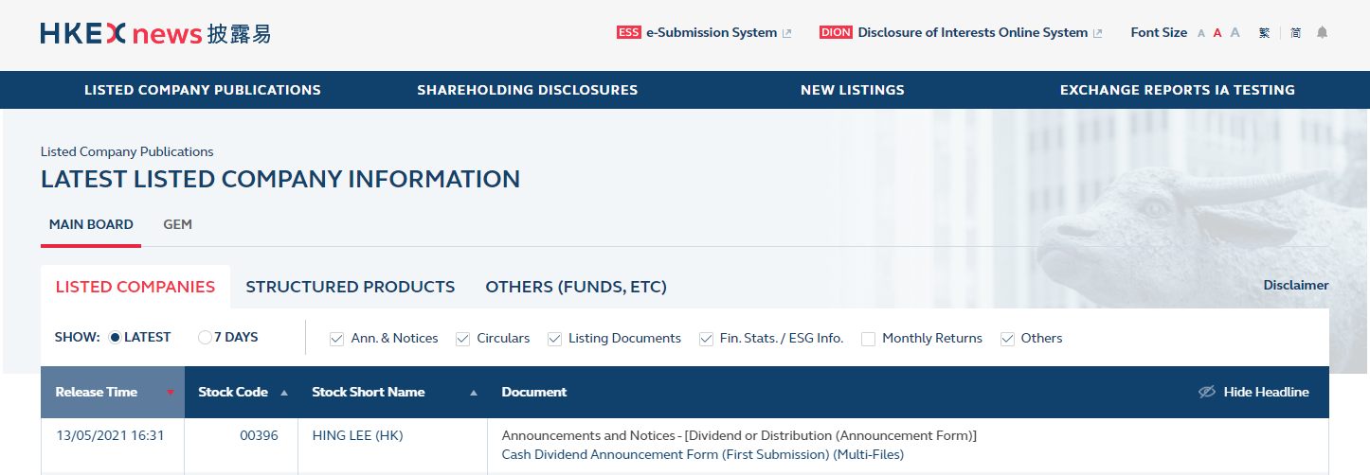
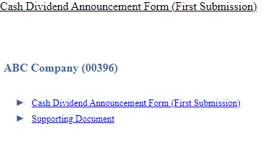

Return e-Forms
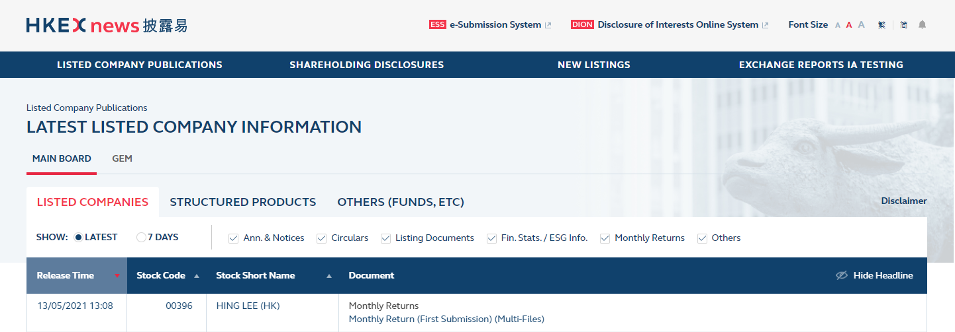
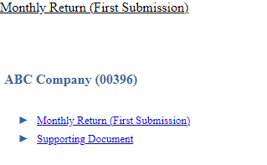

1. Login into ESS as Publication Related Matters user
4. Approve the publication
2. Fill in submission details and select headline category
3. Upload the e-Form, select its Form Type, Previous Related Submission and/or upload additional documents
5. Document published on HKEXnews website

2.7 How will the Announcement Forms and Return e-Forms look like after they are published on the HKEXnews website?
The Announcement Forms and Return e-Forms published on the HKEXnews website will be in a read-only PDF file format which is not editable. Please see below a sample file:

2.8 Are issuers required to publish the Announcement Forms and Return e-Forms on their own website?
Yes, issuers can download the read-only files from the HKEXnews website for publication on their own websites.

Sample scenarios

3.1 What are the sample scenarios for different types of issuers to publish Announcement Forms?

Scenario 1: Cash dividend declared by an A + H issuer

Timetable | Description
Day 1 | The issuer’s directors approved the final results announcement and declared a cash dividend of RMB 0.28 per share. The dividend will be distributed in Renminbi to A-shareholders and Hong Kong dollars to H-shareholders.
Day 10 | The issuer published details of the book closure arrangement for determining the entitlement of the declared cash dividend.
Day 20 | The issuer updated shareholders on the payment date of the dividend, the exchange rate for dividends to be paid in Hong Kong dollars to H-shareholders and the withholding tax arrangement.

Day 1
The issuer should submit two publications on HKEXnews simultaneously:
- Final results announcement in existing announcement format with “Final Results” selected as headline. Where the final results announcement contains information relating to the cash dividend, the headline of “Dividend and Distribution” should also be selected.

- Cash Dividend Announcement Form (EF001) with “Dividend or Distribution (Announcement Form)” selected as headline.

Please note that the issuer should use the Cash Dividend Announcement Form (EF001) in this case as shareholders do not have an option to select the currency for the dividend payment.

Sample of the Announcement Form published at this stage:
Note 1: The Issuer should select “New announcement” in the status field as it is a newly declared cash dividend.
Note 2: The issuer should select “To be announced” for the fields where details are yet to be determined, e.g. book close arrangement or exchange rate for distribution.

Day 10
The issuer should submit another Cash Dividend Announcement Form (EF001) regarding the updates of the book close arrangement with “Dividend or Distribution (Announcement Form)” selected as headline.
Sample of the Announcement Form published at this stage:
Note 1: The issuer should select “Update to previous announcement” in the status field of the Announcement Form and select the relevant previous related submission on the ESS submission screen.
Note 2: The issuer should select “To be announced” for the fields where details are yet to be determined, e.g. exchange rate for distribution.

Day 20
The issuer should submit the third Cash Dividend Announcement Form (EF001) regarding the updates on the remaining details with “Dividend or Distribution (Announcement Form)” selected as headline.
Sample of the Announcement Form published at this stage:
Note 1: The issuer should select “Update to previous announcement” in the status field of the Announcement Form and select the relevant previous related submission on the ESS submission screen.
Note 2: The issuer may upload additional documents with the Announcement Form as supplemental disclosures with consideration to the length and complexity of the information (e.g. withholding tax arrangement) (see Section 2.6 of this FAQ).

Scenario 2: Cash dividend with scrip option declared by an issuer
Timetable | Description
Day 1 | The issuer’s directors approved the interim results announcement and declared a cash dividend of HKD10 per share with scrip option. The book closure arrangement is confirmed.
Day 10 | The issuer published the price for converting cash dividend per scrip share and its calculation mechanism.

Day 1
The issuer should submit two publications on HKEXnews simultaneously:
- Interim results announcement in existing announcement format with “Interim Results” selected as headline. Where the interim results announcement contains information relating to the cash dividend, the headline of “Dividend and Distribution” should also be selected.

- Cash Dividend with Scrip Option Announcement Form (EF003) with “Dividend or Distribution (Announcement Form)” selected as headline.

Sample of the Announcement Form published at this stage:
Note 1: The issuer should select “New announcement” in the status field as it is a newly declared cash dividend.

Note 2: The issuer should select “To be announced” for the fields where details are yet to be determined, e.g. price for converting cash dividend into scrip share.

Day 10
The issuer should submit another Cash Dividend with Scrip Option Announcement Form (EF003) regarding the updates of the price for converting cash dividend into scrip share with “Dividend or Distribution (Announcement Form)” selected as headline.

Sample of the Announcement Form published at this stage:
Note 1: The issuer should select “Update to previous announcement” in the status field of the Announcement Form and select the relevant previous related submission on the ESS submission screen.

Note 2: The issuer may upload additional documents together with the Announcement Form as supplemental disclosures (e.g. detailed narratives of the calculation mechanism of the conversion price) (see Section 2.6 of this FAQ).

Scenario 3: Cash dividend with scrip and currency options declared by an issuer
Timetable | Description
Day 1 | The issuer’s directors approved the third quarterly results announcement and declared a cash dividend of USD2 per share with scrip and currency options available to shareholders. The book closure arrangement is confirmed.
Day 5 | The issuer published the price for converting cash dividend into scrip share.
Day 15 | The issuer published the calculation mechanism on the price for converting cash dividend into scrip share and the arrangement for electing the currency option.

Day 1
The issuer should submit two publications on HKEXnews simultaneously:
- Quarterly results announcement in existing announcement format with “Quarterly Results” selected as headline. Where the quarterly results announcement contains information relating to the cash dividend, the headline of “Dividend and Distribution” should also be selected.

- Cash Dividend with Currency and Scrip Options Announcement Form (EF004) with “Dividend or Distribution (Announcement Form)” selected as headline.

Sample of the Announcement Form published at this stage:

Note 1: The issuer should select “New announcement” in the status field as it is a newly declared cash dividend.

Note 2: The issuer should select “To be announced” for the fields where details are yet to be determined, e.g. price for converting cash dividend into scrip share.

Day 5
The issuer should submit another Cash Dividend with Currency and Scrip Options Announcement Form (EF004) regarding the updates on the price for converting cash dividend into scrip share with “Dividend or Distribution (Announcement Form)” selected as headline.

Sample of the Announcement Form published at this stage:
Note 1: The issuer should select “Update to previous announcement” in the status field of the Announcement Form and select the relevant previous related submission on the ESS submission screen.

Day 15
The issuer should submit another Cash Dividend with Currency and Scrip Options Announcement Form (EF004) regarding the updates on the remaining information with “Dividend or Distribution (Announcement Form)” selected as headline.

Sample of the Announcement Form published at this stage:

Note 1: The issuer should select “Update to previous announcement” in the status field of the Announcement Form and select the relevant previous related submission on the ESS submission screen.

Note 2: The issuer may upload additional documents together with the Announcement Form as supplemental disclosures (e.g. detailed narratives of the calculation mechanism of the conversion price) (see Section 2.6 of this FAQ).

Scenario 4: Special and ordinary cash dividends declared by an issuer

Timetable | Description
Day 1 | The issuer’s directors approved the interim results announcement and declares a special cash dividend of HKD1 per share and an ordinary cash dividend of HKD0.5 per share.

Day 1
The issuer should submit three publications on HKEXnews simultaneously:
- Interim results announcement in existing announcement format with “Interim Results” selected as headline. Where the interim results announcement contains information relating to the cash dividends, the headline of “Dividend and Distribution” should also be selected.

- For the special cash dividend: Cash Dividend Announcement Form (EF001) with “Dividend or Distribution (Announcement Form)” selected as headline.

Sample of the Announcement Form published at this stage:
Note 1: The issuer should select “New announcement” in the status field as it is a newly declared cash dividend.

Note 2: The issuer should select “special” in the “dividend nature” field.

- For the ordinary cash dividend: Cash Dividend Announcement Form (EF001) with “Dividend or Distribution (Announcement Form)” selected as headline.

Sample of the Announcement Form published at this stage:

Note 1: The issuer should select “New announcement” in the status field as it is a newly declared cash dividend.

Note 2: The issuer should select “ordinary” in the “dividend nature” field.

Scenario 5: Special cash dividend and bonus issue of shares declared by an issuer

Timetable | Description
Day 1 | After completion of a disposal, the issuer’s directors declared a special cash dividend of HKD1 per share and a bonus issue of shares (2 bonus shares for 1 share held). The dividend/ bonus issue of shares are not declared for any particular financial year / period.

Day 1
The issuer should submit two publications on HKEXnews simultaneously:
- For the special cash dividend: Cash Dividend Announcement Form (EF001) with “Dividend or Distribution (Announcement Form)” selected as headline.

Sample of the Announcement Form published at this stage:
Note 1: The issuer should select “New announcement” in the status field as it is a newly declared cash dividend.

Note 2: As the dividend is not declared for a particular financial year /period, the issuer should select “Not applicable” in the “For the financial year / period end” field.

- For the bonus issue of shares: Bonus Issue of Shares or Warrants Announcement Form (EF005) with “Bonus Issue (Announcement Form)” selected as headline.

Sample of the Announcement Form published at this stage:
Note 1: The issuer should select “New announcement” in the status field as it is a new bonus issue.

Note 2: As the bonus issue is not related to a particular financial year / period, the issuer should select “Not applicable” in the “For the financial year / period end” field.

Exception scenario handling

4.1 What should an issuer do if it notes certain incorrect contents (e.g. wrong “status” or incorrect payment date) in a previously published Announcement Form or Return e-Form?

Note: Please note that issuer needs to cancel the Announcement Form or Return e-Form with wrongly selected “status” field. Please refer to Section 4.2 of this FAQ for the cancellation procedures.

Announcement Forms
- The issuer should publish a new Announcement Form with the revised contents, choose “Update to previous announcement” in the “status” field and provide the reason for the update / change.
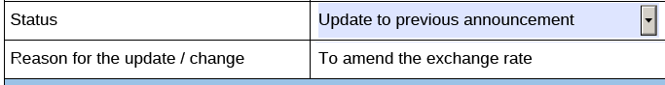
- When the issuer submits the new Announcement Form through ESS, it should select the previously published Announcement Form that it wishes to update or amend.
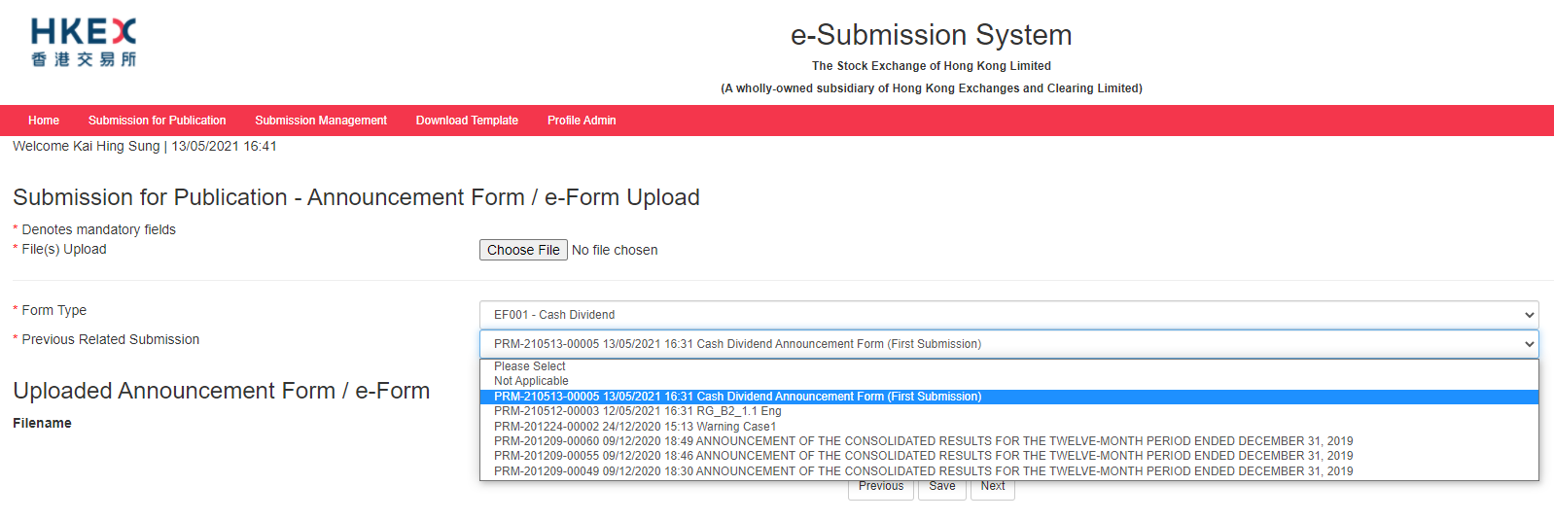
Return e-Forms
- The issuer should publish a new Return e-Form with the revised contents, and select “Resubmission” in the “status” field.
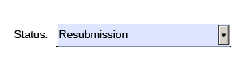

- When the issuer submits the new Return e-Form through ESS, it should select the previously published Return e-Form that it wishes to update or amend.
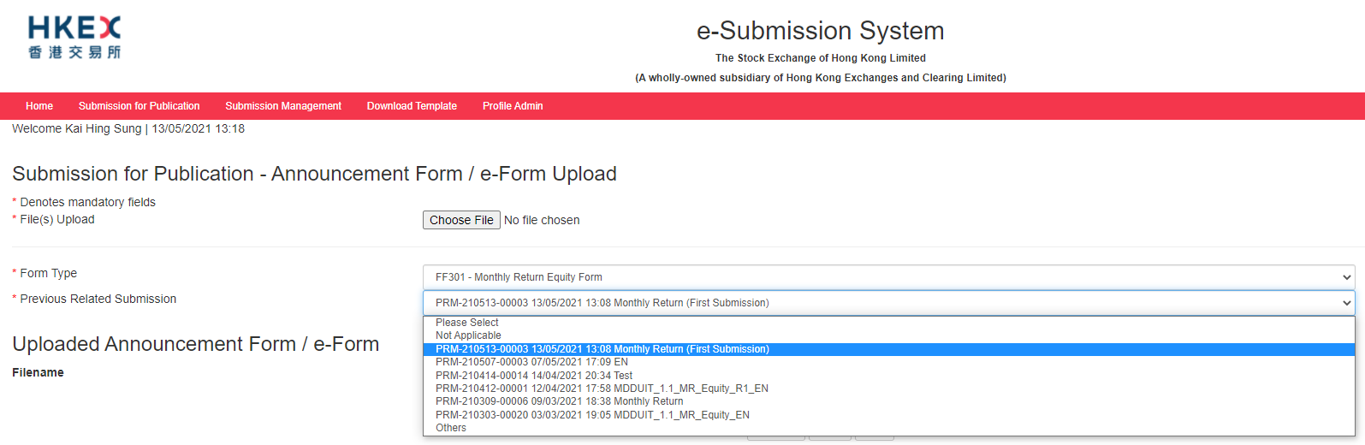

4.2 What should an issuer do in the following circumstances?
- It has wrongly selected the “status” field of a published Announcement Form or Return e-Form;
- It has submitted duplicated copies of an Announcement Form or Return e-Form which resulted in two identical publications on the HKEXnews website; or
- It has submitted a wrong Announcement Form or Return e-form which should not have been published.

- The issuer should make a written request by email to HKEX (ESSHotline@hkex.com.hk) to cancel the wrong/ duplicated Announcement Form or Return e-Form. The issuer should provide the cancellation reasons (i.e. wrong “status” field or duplicated submission) and details of the wrong publication (e.g. Announcement Form published on dd/mm/yyyy at HH:MM) in the request email.

- The issuer should publish a new Announcement Form or Return e-Form with correct information through ESS as appropriate.
Please note that HKEX will add a prefix (e.g. “Cancelled and Re-issued”, “Cancelled [Duplicate Copy]” or “Cancelled [Incorrect Submission]”) at the beginning of the headline of the cancelled publication and the contents of the cancelled publication will still be viewable on the HKEXnews website.

4.3 What should an issuer do if it notes that there is an error red box in the e-Forms even with all the mandatory fields filled in?
The issuer needs to save and reopen the e-Form document. After that, it should be able to submit the e-Form as usual.

